**Appendix A: Database Table Schema and Sample Data**

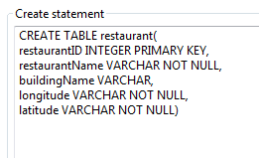  
Figure 1: Code Snippet and schema of the “restaurant” table

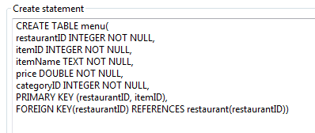  
Figure 2: Code Snippet and schema of the “menu” table

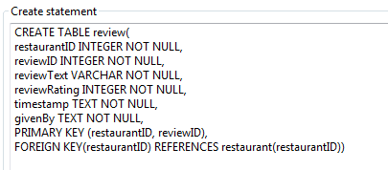  
Figure 3: Code Snippet and schema of the “review” table

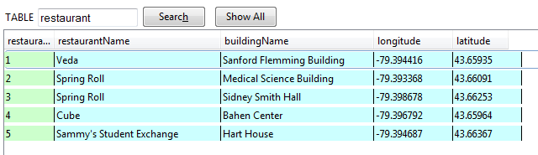

Figure 4: Sample data in “restaurant” table

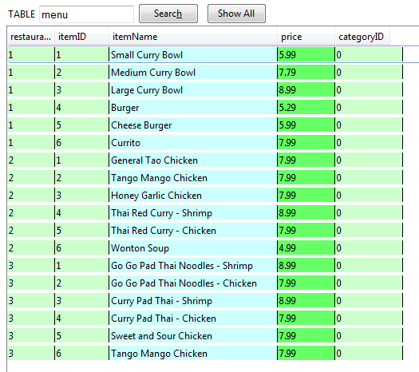  
Figure 5: Sample data in “menu” table

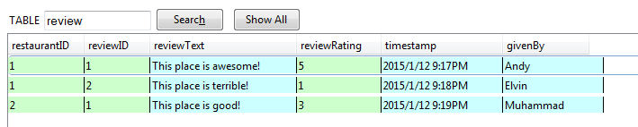

Figure 6: Sample data in “review” table